The Battle Is Not Over Yet & Lonely Christmas for Some
December 23, 2016

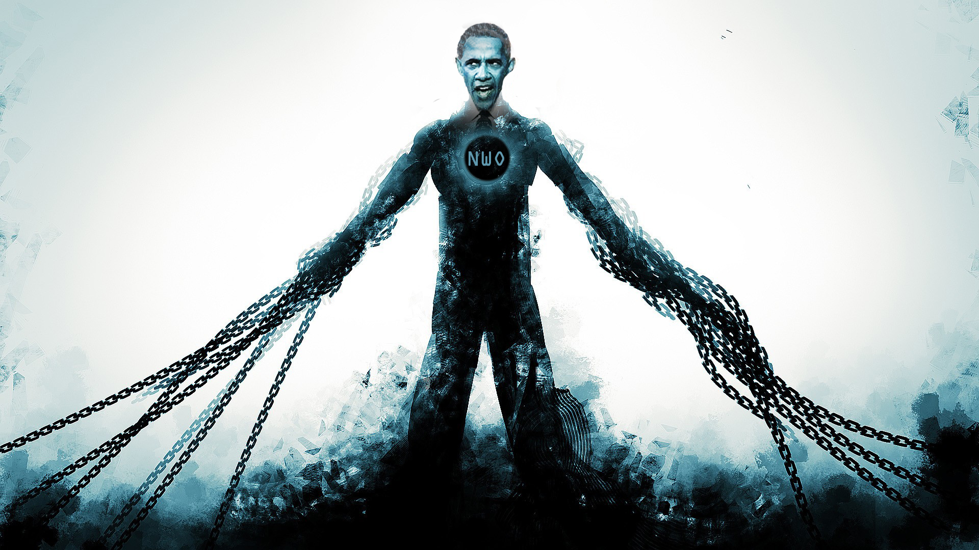
May the consolation of our dear Lord Jesus fill your hearts this day, beloved ones.

We've been having administrative growing pains, so that's the really why I'm a little delayed on the messages. But we're getting all caught up and we have everybody in place. I'm glad to announce that your prayers have made a huge difference. Things are beginning to pick up and roll along smoothly.

The portrait of the Lord should be done very soon. I'm trying to get it done by Christmas and photographed and up on the website, but I'm afraid I'm not going to make it. So forgive me for that. Keep up the good prayers!

Your prayers have had an impact. Your refusal to be distracted and quick return to your knees has bound momentarily the wicked plans of those who hate the Lord and this country.

Carol had a vision while praying. She saw Obama caught in a huge spider web that was attached and connected around the whole world. He was the spider in the center, and he was bound in chains and unable to move. Carol had the impression that the points of the web were waiting for Obama to make the first move, but he couldn’t because he was chained by our prayers. She also had the impression that the next week and beyond would still require prayers to keep him immobile.

And after I pondered this vision that she had, the Lord began speaking.

“The battle is not over yet, dear ones of My Heart. It is not over yet. For the time being you have bound him in chains, but not for long, if you do not continue to fast and pray. This man is diabolical and determined to put an end to America. In this moment, he is stewing in his own bitter juices because he cannot as yet touch you. But that will come to an end if you don’t keep up your efforts to bind him, for there are many devices and powers of evil involved in this wicked subterranean government.

“And that is truly what you have, a hellish government formed underground quite literally, and figuratively, as well. Conceived and executed from Hell and I am about to despoil it - if you hold your ground in prayer. As I have told you before, I am giving this world a demonstration of what a Christian country can do through prayer.

"Then it is up to them to choose to fight this wickedness and put a temporary end to it, or allow it to consume the world in the flames of corruption. Muslims and Christians alike will have to denounce this evil force in order for it to be contained for any length of time.

"But understand even as it is written, “Ishmael will be a wild donkey of a man; his hand will be against everyone and everyone's hand against him, and he will live in hostility toward all his brothers." Genesis 6:12

"And it is the way of history that men use one another for their own ends and then terminate them. And so shall it be with the new world government. They will use the Muslims to destroy the Christians and Jews and then they themselves shall be destroyed. For the people will rebel against this insidious ideology. But remember I will come and put an end to all dictatorships and all governments that are not of Me, established by and for the Kingdom of Heaven.

"But in the meantime, the Earth will be a living hell after you, My Bride, are removed. But for now, My Mercy is anxious to demonstrate the possibilities of living for God in a truly free country. All nations will be given the chance to fight their way out of the kingdom of darkness.

"Now you, My Bride, have proven yourselves trustworthy with My Heart. You have shown that your first love is Me and not the demanding traditions of men. I have told you before, this season used to celebrate My Incarnation, and holds many magical and holy moments for the young. My angels are present in so many places to stir the young hearts towards their Savior.

"Satan has perverted this holy day with materialism, but such young souls are not old enough quite yet to understand that. To them, it is a season of giving to those you love and a celebration even with Christmas carols which I anoint to move on the hearts of men. Yes, in these rooms with families singing to Me, the anointing of love and peace falls heavily almost like an intoxicating happiness."

You know, as He was talking about that, I just had memories of my children when they were younger, and the beautiful traditions that we had to celebrate the Lord's birth. And I started to feel really sad.

And the Lord interrupted my sadness and said, "The day is coming, Clare. The fulfillment of all is coming. My promises to you, that your children will return to their roots will not return to Me void. I will see the day when you will worship as a family and light the candles of faith and devotion to Me. I will see the day, My love, and so will you.”

(He lifted my chin as tears were streaming from my eyes…it hurts so badly to have lost them to the world.)

"The world had an irresistible draw on them, Clare. Understand, even the Mennonite children go astray, and when they face Me, they will not be able to blame it on their parents. And neither will yours."

Oh, my precious friends, there is no time of the year that hurts more than this time for Ezekiel and I. We both have children who have gone astray and those memories are enough to buckle our knees.

The Lord continued, "But you shall not grieve, Clare, you shall not. I wish for you to raise your countenance to Me and to the Hope I have promised and do not allow the enemy to magnify the feelings of grief that sneak up on you.

"So much, My people, you do not understand about the restoration I am going to bring about in Heaven. Everything that was done the wrong way, will be rewritten. It is beyond your comprehension to understand that now, but when so- called time wraps up, there will be seasons of return and restoration. I will see each of you the way you were meant to be raised as children and each of you as you were meant to be the perfect parents.

"Every tear shall indeed be wiped away. As it is written. “He will wipe away every tear from their eyes, and death shall be no more, neither shall there be mourning, nor crying, nor pain anymore,” Revelation 21:4

"The greatest travesty of the modern-day church is the apostasy of portraying My words as only figurative. They are not figures of speech used to communicate other concepts. They are LITERAL - without gloss, without alteration. And all that is written shall be fulfilled. Every tear shall be wiped away from your eyes. All shall be understood even as I understand and in the impartation of this knowledge it will be impossible for you to cry any longer.

"Clare, you are not the only one suffering from nostalgic memories. Every broken family suffers during this season and that is why so many are depressed. Satan has again taken what is precious and turned it against man, but I shall in the end triumph.

"Please, My people, do not allow yourselves to be drawn off course for this next week. Continue to press in and declare the victory of My grace over this evil abomination. Continue to hold the wheel of destiny firmly in your praying hands - firmly, never being called away by distraction. Your lives - Your very lives depend upon this.

"I must tell you this is part of your next level. You are the ones who are going to reform this world for a short time, with your prayers. You are the ones who are clearing the way for My will to be done in administrating this country. You have taken strategic ground, now you must hold fast to it.

"There will be sorties."

I looked that up in the dictionary, and it said, "an attack made by troops coming out from a position of defense."

So He said, "There will be sorties into new territory if this ground continues to be held and President Trump implements the means to reform your government. But you will still be defending the ground that you have taken and keeping him alive, in office and healthy through your prayers.

"Part of your climb up the mountain is the increased power of intercession and anointing on each of you to pray the very prayers needed to continue on. I know this has been a steep climb. I know how much each of you have suffered and offered to Me as fast offerings. And I am well-pleased with you, My People. So very pleased that you hearkened to My cries for your assistance in prayer.

"I am not a God who does not want and need His people. I have allowed Myself to be dependent on your prayers to win decisive victories. Yes, I have placed My very self inside of you and watched as we piloted this ship together. I have made Myself dependent upon your prayers, because you are co-creators with Me, in that your free will minds, when aligned with Mine, bring forth marvelous fruit. Yes, I am the Vine, you are the Branches and together we produce the finest of harvests.

"All I have to say to you now is to stand your ground, Beloved. Stand and behold the salvation of your God. Do not grow lax, weary or distracted in prayer. Make every sacrifice - no matter how small - an offering for My Kingdom come, My will be done. Dress each gift in the wrappings of thanksgiving and praise. Truly, My Father in Heaven has copious gifts from all of you. He celebrates your faithfulness in this season.

"Continue to hold ground, the fight is not over quite yet.

"May your hearts be filled with the knowledge of My love for you. May you understand more fully the impact you are having on this world. May you never grow weary of the climb but rather keep before you the view at the top and the great celebration we will soon have together in Heaven.

"I impart these graces to you now. Tuck them away, tenderly in your hearts, and protect them. You are My victorious Bride!"

The book Rhema is finished! Carol has edited it and put it together, and it's wonderful. It's the prophecies and admonitions, teachings of the Lord from our channel. And it's compiled by subject. You can get it on Amazon. So I want to encourage you, it's a beautifully put together book and very, very powerful. Exhortations and teachings from the Lord.

God bless you, Heartdwellers. Thank you for being a part of our lives. We love every one of you, even our enemies.

